VANASTHALI PUBLIC SCHOOL

Computer Science Program File

Q. Program to calculate simple interest using a function interest() that can receive principal amount , time and rate and returns calculated simple interest. Do specify default values for rate and time as 10% and 2 years respectively.

CODE:-
def interest(principal,time=2,rate=0.10):
return principal*rate*time
#__main__
Prin=float(input('Enter principal amount:'))
print("Simple interest with default ROI and time value is:")
Si1=interest(Prin)
print("Rs.",Si1)
Roi=float(input("Enter rate of interest:"))
time=int(input("Enter time in years:"))
print("Simple interest with your provided ROI and time value is:")
Si2=interest(Prin,time,Roi)
print("Rs.",Si2)

OUTPUT:-
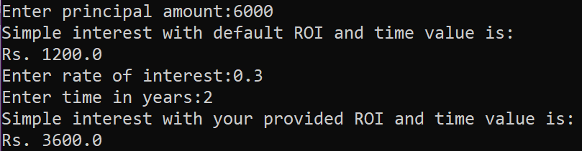
Q. Given a dictionary with values list, extract key whose value has most unique values.
CODE:-

test_dict = {"Gfg" : [5, 7, 5, 4, 5],
"HANG" : [6, 7, 4, 3, 3],
"Best" : [9, 9, 6, 5, 5]}
print("The original dictionary is : " + str(test_dict))
max_val=0
max_key=None
for sub in test_dict:
if len(set(test_dict[sub]))>max_val:
max_val=len(set(test_dict[sub]))
max_key=sub
print("Key with maximum unique values : "+ str(max_key))
OUTPUT:

Q. Define a function having a variable as its argument and check whether the string is palindrome or not.

CODE:-

def pallindrome(string):
newstr=""
for w in range (-1,-len(string)-1,-1):
newstr=newstr+string[w]
if newstr==string:
print(string,"is a pallindrome")
else:
print(string,"is not a pallindrome")
var=input("Enter String:")
pallindrome(var)
OUTPUT:-
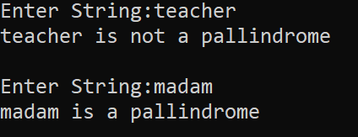

Q. Define a function to input a number and check whether the given number is Armstrong number or not .
(Note: If a 3 digit number is equal to the sum of the cubes of its each digit , then it is an Armstrong number )

CODE:-

def armstrong():
num=int(input("Enter a 3 digit number:"))
su=0
for w in str(num):
su=su+int(w)**3
if num==su:
print(num,"is an Armstrong number")
else:
print(num,"is not an Armstrong number")
armstrong()
OUTPUT:-
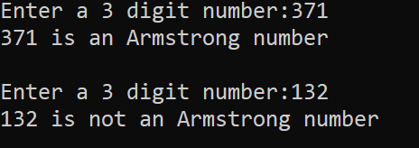

Q. Write a program to print the following pattern :

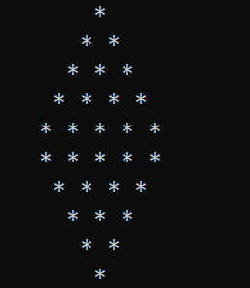
CODE:-

n=5 #for number of lines
# upper half
for i in range(1,n+1):
print(" "," "*(n-i)+"* "*i)
# lower half
for i in range(n,0,-1):
print(" "," "*(n-i)+"* "*i)

Q. Program to find frequencies of all elements of a list .Also , print the list of unique elements in the list and duplicate elements in the given list.

CODE:-
lst=eval(input("Enter list:"))
lstc=list(lst)
uniq=[]
dupl=[]
for element in lst:
c=0
for w in lst:
if element==w:
c=c+1
if c==1:
uniq.append(element)
print('Element',element,'frequency',c)
for q in lstc:
if lst.count(q)==1:
pass
else:
for w in range(len(lstc)-1):
if lstc[w]==q:
print('Element',q,'frequency',lstc.count(q))
dupl.append(q)
lstc.pop(w)
print('Original List:',list(lst))
print('Unique Elements List',uniq)
print('Duplicates Elements List',dupl)

OUTPUT:-
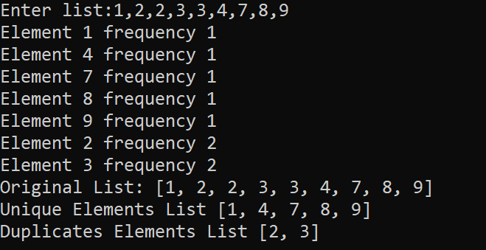

Q. Define a function to check if the elements in the first half of a tuple are sorted in ascending order or not.

CODE:-

tup = eval(input("Enter a tuple:"))
ln = len(tup)
mid = ln//2
if ln % 2 == 1:
mid = mid + 1
half = tup[:mid]
if sorted(half) == list(tup[:mid]):
print("First half is sorted")
else:
print("First half is not sorted" def tuplehalf():
tup=eval(input("Enter a tuple:"))
ln=len(tup)
mid=ln//2
if ln%2==1:
mid=mid+1
half=tup[:mid]
if sorted(half)==list(tup[:mid]):
print("First half is sorted")
else:
print("First half is not sorted")

tuplehalf()

OUTPUT:-
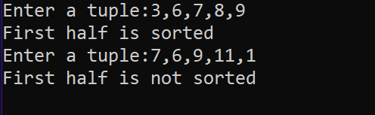
Q. Program to count the frequency of a list of elements using a dictionary.

CODE:-

sentence="This is a super idea This idea will change the idea of learning"
words=sentence.split()
d={}
for one in words:
key=one
if key not in d:
count=words.count(key)
d[key]=count
print("Counting frequencies in list \n",words)
for w in d:
print(" "+w.ljust(15),str(d[w]).ljust(3))
OUTPUT:-
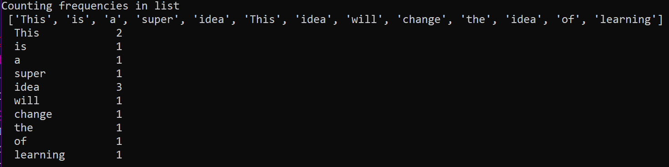

Q. Write a program to create a dictionary with the roll number, name and marks of n students in a class and display the names of students who have marks above 75.

CODE:-
n=int(input("How many Students?"))
stu={}
for i in range(1,n+1):
print()
print("Enter details of student",(i))
rollno=int(input("Roll number:"))
name=input("Name:")
marks=float(input("Marks:"))
d={"Rollno" :rollno,"Name":name,"Marks": marks}
key="Stu"+str(i)
stu[key]=d
print("Students with marks > 75 are:")
for i in range(1,n+1):
key="Stu"+str(i)
if stu[key]["Marks"]>=75:
print(" RollNo".ljust(8),str(stu[key]["Rollno"]).ljust(3)," Name".ljust(6),str(stu[key]["Name"]).ljust(20)," Marks".ljust(7),str(stu[key]["Marks"]).ljust(20))

OUTPUT
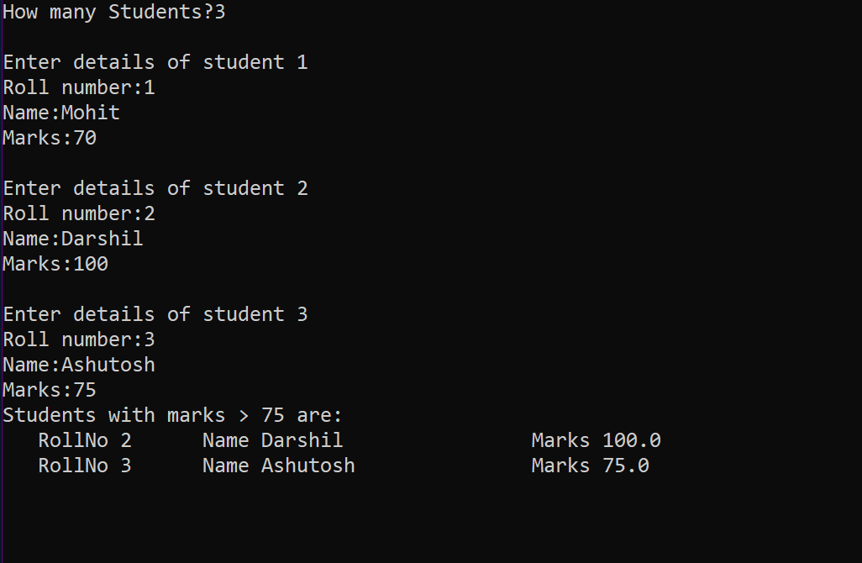

Q. Read a text file x.txt and built y.txt that should be reverse of x. txt
CODE:-

def reverse(x,y):
fx=open(x,"r")
fy=open(y,"w+")
k=fx.readlines()
for w in range(-1,-len(k)-1,-1):
x=k[w].rstrip("\n")
line=x
newlin=""
for i in range (-1,-len(line)-1,-1):
newlin=newlin+line[i]
print(newlin)
fy.write(newlin+"\n")
reverse("Abc.txt","NewAbc.txt")
OUTPUT:-
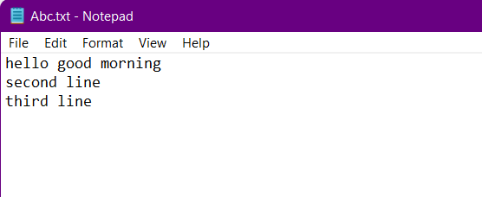
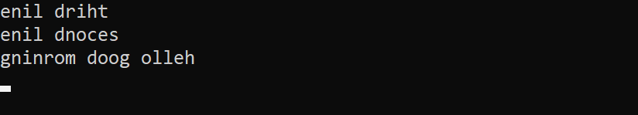
Q. Program to sort a sequence using insertion sort.

CODE:-

aList = [15,6,13,22,3,52,2]
print("Original list is:",aList)
for i in range(1,len(aList)):
key=aList[i]
j=i-1
while j>=0 and key<aList[j]:
aList[j+1]=aList[j]
j=j-1
else:
aList[j+1] = key
print("List after sorting:",aList)
OUTPUT:-
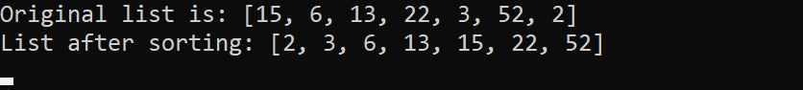

Q. Program to sort a list using bubble sort.

CODE:-

alist = [15,6,13,22,3,52,2]
print("original list is:",alist)
n=len(alist)
for i in range(n):
for j in range(0,n-i-1):
if alist[j]>alist[j+1]:
alist[j],alist[j+1]=alist[j+1],alist[j]
print("list after sorting:",alist)
OUTPUT:-
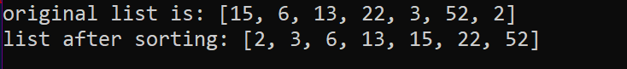

Q. Write a program that inputs main string and then creates an encrypted string by embedding a short symbol based string after each character . The program should also be able to produce the decrypted string from encrypted string.

CODE:-

def encrypt(sttr,enkey):
return enkey.join(sttr)
def decrypt(sttr,enkey):
return sttr.split(enkey)
#-main
mainstring = input("enter main string:")
encryptstr = input("enter encryption key:")
enstr=encrypt(mainstring,encryptstr)
delst=decrypt(enstr,encryptstr)
destr="".join(delst)
print("the encrypted string is",enstr)
print("string after dcryption is:",destr)
OUTPUT:-
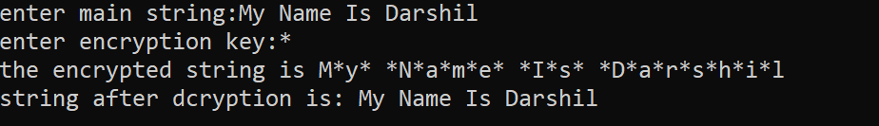

Q. Define a function having a text file name as it's argument. The function should return a Dictionary having key as line number of text file and values list of two integers [number of upper case alphabets and number of lower case alphabet ] in each line.

CODE:-

def fx(file):
z=0
di={}
f=open(file,"r")
lst=f.readlines()
for line in lst:
z=z+1
uc=0
lc=0
for word in line:
if word.isupper():
uc=uc+1
elif word.islower():
lc=lc+1
di[z]=[lc,uc]
return di

y=fx("Abc.txt")
print(y)


OUTPUT:-
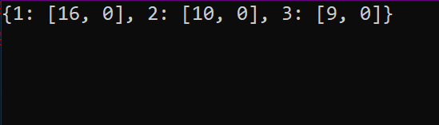

Q. Write a program to read a text file line by line and display each word separated by a ‘#’.

CODE:-

myfile=open("answer.txt","r")
line=" "
while line:
line=myfile.readline()
for word in line.split():
print(word,end='#')
myfile.close()

FILE CONTENTS
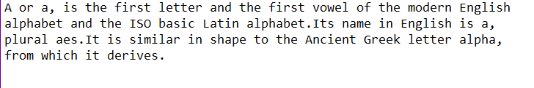
OUTPUT:-

Q. Write a program to read a text file and display the count of vowels and consonants in the file.

CODE:-

myfile = open("answer.txt","r")
ch=" "
vcount=0
ccount=0
while ch:
ch=myfile.read(1)
if ch in['a','A','e','E','i','I','o','O','u','U']:
vcount=vcount+1
else:
ccount=ccount +1
print("vowels in the file:",vcount)
print("consonants in the file:",ccount)
myfile.close()
FILE CONTENTS
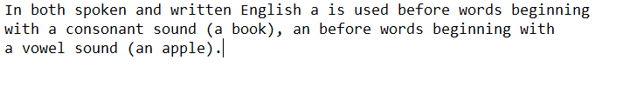
OUTPUT:-

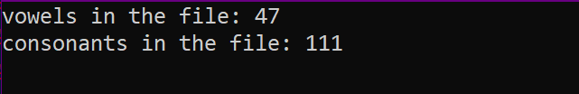

Q. Write a program to get student data(roll no. , name and marks) from user and write onto a binary file. The program should be able to get data from the user and write onto the file as long as the user wants.

CODE:-

import pickle
stu={}
stufile=open('Stu.dat', 'wb')
ans='y'
while ans=='y' or ans='Y':
rno=int(input("Enter roll number : "))
name=input("Enter name :")
marks=float(input("Enter marks : "))
stu['Rollno']=rno
stu['Name']=name
stu['Marks']=marks
pickle.dump(stu, stufile)
ans=input("Want to enter more records? (y/n)...")
stufile.close()
OUTPUT:-
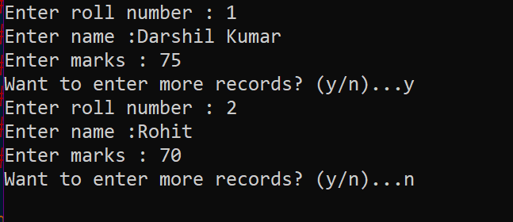
Q. Write a program to append student records to file created in previous program, by getting data from user.

CODE:-

import pickle
stu={ }
stufile=open('Stu.dat', 'ab')
ans='y'
while ans=='y' or ans=='Y':
rno=int(input("Enter roll number :"))
name=input("Enter name :")
marks=float( input("Enter marks: "))
stu['Rollno']=rno
stu['Name']=name
stu['Marks']=marks
conf=input('Confirm(y/n):')
if conf=='Y' or conf=='Y':
pickle.dump(stu,stufile)
ans = input("Want to append more records? (y/n)...")
stufile.close()

OUTPUT:-
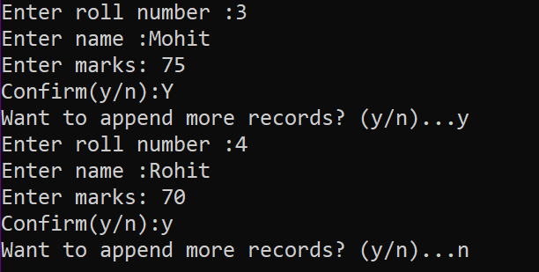
Q. Write a program to open file Stu.dat and search for records with roll numbers as 46 or 48 . If found display the records.
CODE:-

import pickle
stu={}
found=False
fin=open('Stu.dat', 'rb')
searchkeys=[46, 48]
try:
print("Searching in File Stu.dat ...")
while True :
stu=pickle.load(fin)
if stu['Rollno'] in searchkeys:
print(stu)
found=True
except EOFError:
if found==False :
print("No such records found in the file")
else:
print("Search successful.")
fin.close()
OUTPUT:-
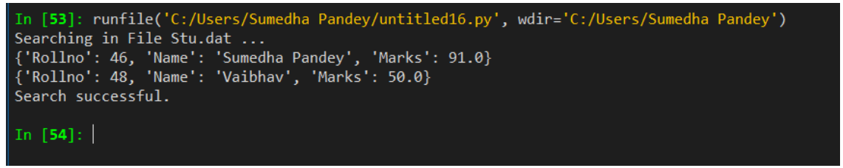

Q. Define a function reading few lines from the user in a list until an empty line is given as input and count the lines contains a word cat in it.
def fx():
k=[]
while True:
x=input("Enter a Line:")
if x=="":
break
else:
k.append(x)
print(k)
c=0
for w in k:
y=w.split()
if "cat" in y:
c=c+1
print("Count of lines containing cat",c)
fx()

OUTPUT:-
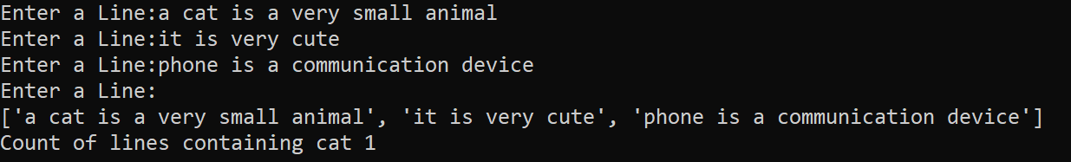

Q. Write a program to read following details of sport’s performance (sport , competitions, prizes-won) of your school and store into a csv file delimited with tab character .

CODE:-

import csv
fh=open("Sport.csv","w")
writer=csv.writer(fh,delimiter='\t')
writer.writerow(['Sport','Competitions','Prizes won'])
ans='y'
i=1
while ans=='y':
print("Record", i)
sport=input("Sport name:")
comp=int(input("No. of competitions participated :"))
prizes=int(input("Prizes won:"))
srec=[sport,comp,prizes] # create sequence of user data
writer.writerow(srec)
i=1+1
ans=input("Want to enter more records? (y/n)..")
fh.close()

OUTPUT:-
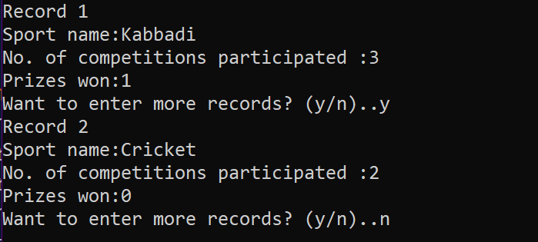
TERM 2
Q. Write a python program that displays a first three rows fetched from student table of MySQL database “supermarket”.

CODE:-

import mysql.connector as con
c=con.connect(host="localhost",user="root",passwd="123456",database="supermarket")
if c.is_connected() == False:
print('Error connecting to MySQL database')
crsr=c.cursor()
crsr.execute("select * from product")
data=crsr.fetchmany(3)
count=crsr.rowcount
for row in data :
print(row)
c.close()
OUTPUT:-

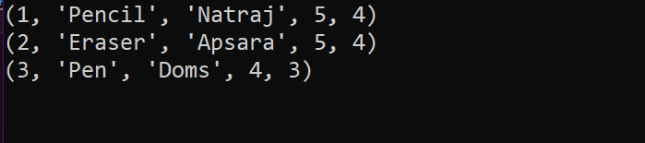
Q.Write a program to build a table named as stationary with attributes Id, name, price, company Id is primary key Add records until user want and display same
CODE:-
z=0
import mysql.connector as con
while z==0:
try:
pswd=input("Enter Password:")
dbobj=con.connect(host="localhost",user="root",password=pswd,charset="utf8")
z=1
except:
print("Wrong Password")
crsr=dbobj.cursor()
def db():
crsr.execute("CREATE DATABASE IF NOT EXISTS SAMPLE;")
crsr.execute("commit")
crsr.execute("USE SAMPLE;")
crsr.execute("commit")
crsr.execute("CREATE TABLE IF NOT EXISTS STATIONARY(Id int Primary key,Name char(20),Price int,Company char(20));")
crsr.execute("commit")
db()

def que():
y=0
print("Enter ID as 0 to exit")
while y==0:
try:
i=int(input("Enter ID:"))
if i==0:
y=1
else:
name=input("Enter Name:")
price=int(input("Enter Price:"))
company=input("Enter Company:")
lst=(str(i),name,str(price),company)
print(lst)
confirm=input("Confirm(Y/N):")
if confirm=="Y" or "y":
crsr.execute("INSERT INTO STATIONARY VALUES ('{}','{}','{}','{}')".format(i,name,price,company))
crsr.execute("commit")
except:
print("Some ERROR")

def dis():
print()
print("-"*85)
crsr.execute("DESC STATIONARY;")
recs=crsr.fetchall()
print("%3s %-10s %-5s %5s"%(recs[0][0],recs[1][0],recs[2][0],recs[3][0]))
crsr.execute("select * from STATIONARY;")
recs=crsr.fetchall()
for rec in recs:
print("%3s %-10s %5s %5s"%(rec[0],rec[1],rec[2],rec[3]))
que()
dis()

OUTPUT:- 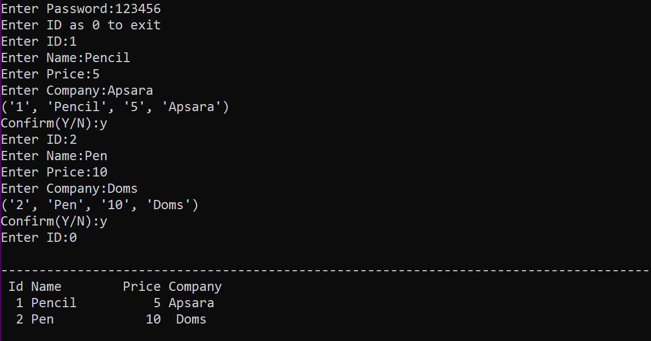

Q.Write a python databses connectivity program that delete records from sample table of database sample .
CODE:-
import mysql.connector as c
con=c.connect(host='localhost',user='root',password='',database='sample',charset='utf8')
if con.is_connected():
print('Successfully connected')
cursor=con.cursor()
print('Displaying records before deleting..............')
cursor.execute('select*from stationary')
data=cursor.fetchall()
for a in data:
print(a)
nme=input('Enter the name for deleting the record :-')
que='delete from stationary where name="%s"'%(nme)
cursor.execute(que)
print()
cursor.execute('select*from stationary')
data=cursor.fetchall()
print('Displaying records after deleting.......')
for w in data :
print(w)
con.commit()
con.close()
print('Record deleted completely.......')

OUTPUT :-
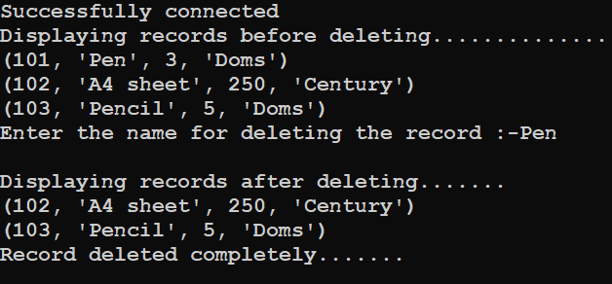

Q. Define a function named as db to create a new database named as school.

CODE

import mysql.connector as c
con=c.connect(host='localhost',user='root',password='',charset='utf8')
if con.is_connected():
print('succesfully connected..........')
cursor=con.cursor()

def db():
que='create database if not exists school'
cursor.execute(que)
print('Database created...')
db()
OUTPUT:-

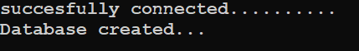
Q. Define a function table() to create a new table named as class_12 with attributes Name, Class, Roll_no,section and Gender in database named as school.

CODE
import mysql.connector as c
con=c.connect(host='localhost',user='root',password='',database='school',charset='utf8')
if con.is_connected():
print('succesfully connected..........')
cursor=con.cursor()

def tb():
cursor.execute('create table if not exists class_12(Rno int primary key,Name varchar(15),Class int,Sec varchar(10),Gender varchar(15))')
print('Table is created...')
tb()

OUTPUT:-

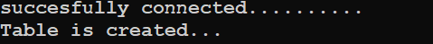
Q.Define a function insert to add the details of three students in the table class_12 in database school.

CODE
import mysql.connector as c
con=c.connect(host='localhost',user='root',password='',database='school',charset='utf8')
if con.is_connected():
print('succesfully connected..........')
cursor=con.cursor()

def insert():
try:
for w in range(3):
print()
print('Entering the',w+1,'record')
rno=int(input('Enter rno: '))
name = input('Enter name:')
Class=int(input('Enter class:'))
sec=input('Enter section:')
gender=input('Enter Gender: ')
query='Insert into class_12 values({},"{}",{},"{}","{}")'.format(rno,name,Class,sec,gender)
cursor.execute(query)
con.commit()
con.close()
print('Record is succesfully inserted........')

except:
print("Some Error")
insert()
OUTPUT

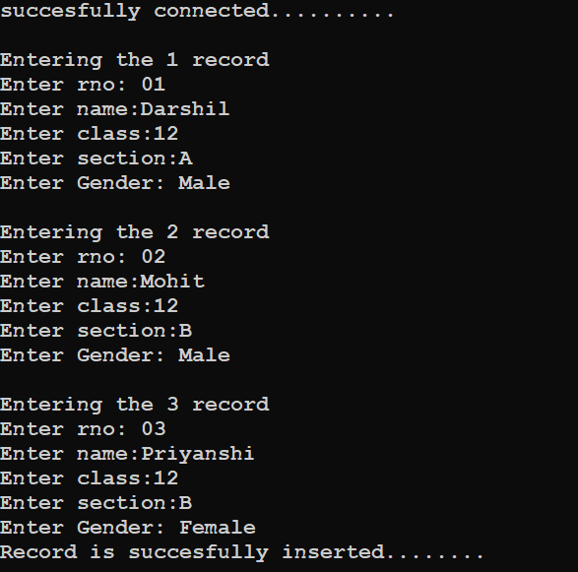

Q. Define a function named as update() to update the records of the students taken from user of table class_12 in database school.
CODE
import mysql.connector as c
con=c.connect(host='localhost',user='root',password='',database='school',charset='utf8')
if con.is_connected():
print('succesfully connected..........')
cursor=con.cursor()
def update():
rno=int(input('Enter roll number:'))
cursor.execute('desc class_12')
recs=cursor.fetchall()
print(recs[0][0].ljust(8),recs[1][0].ljust(20),recs[2][0].ljust(10),recs[3][0].ljust(10),recs[4][0].ljust(10),sep='')
cursor.execute('select * from class_12 where rno={}'.format(rno))
w=cursor.fetchall()
for rec in w:
print(str(rec[0]).ljust(8),rec[1].ljust(20),str(rec[2]).ljust(10),rec[3].ljust(10),rec[4].ljust(10),sep='')
print('''
1)Name
2)Class
3)Gender
4)Section''')
print()
ch=int(input('Enter Here:'))
if ch==1:
name=input('Enter new name :')
cursor.execute('update class_12 set name="%s" where rno=%d'%(name,rno))
con.commit()
print('Record updated........')
elif ch==2:
clas=int(input('Enter new class :'))
cursor.execute('update class_12 set class=%d where rno=%d'%(clas,rno))
con.commit()
print('Record updated........')
elif ch==3:
gender=input('Enter the new Gender :')
cursor.execute('update class_12 set gender="%s" where rno=%d'%(gender,rno))
con.commit()
print('Record updated.........')
elif ch==4:
sec=input('Enter new Section :')
cursor.execute('update class_12 set sec="%s" where rno=%d'%(sec,rno))
con.commit()
print('Record updated........')
else:
print('WRONG CHOICE !!!!!!!!')
con.close()
update()

OUTPUT:-

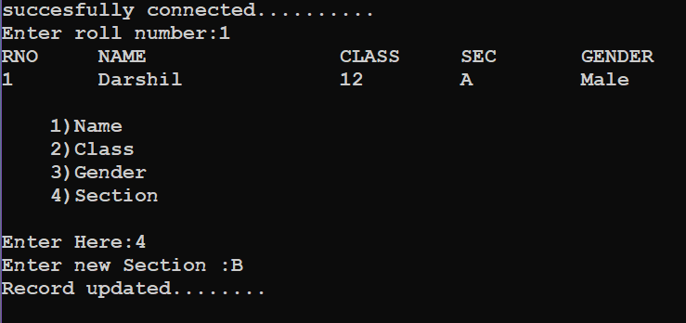
Q.Define a function del() to delete the records of the table class_12 of database school.

CODE
import mysql.connector as c
con=c.connect(host='localhost',user='root',password='',database='school',charset='utf8')
if con.is_connected():
print('succesfully connected..........')
cursor=con.cursor()

def delete():
while True:
print('''
1)Delete all
2)Delete with Rno''')
ch=int(input("Enter Choice:"))
if ch==1:
que='Delete from class_12'
cursor.execute(que)
elif ch==2:
rn=int(input('Enter Roll number: '))
query='delete from class_12 where rno={}'.format(rn)
cursor.execute(query)
else:
print('WRONG CHOICE.....')
con.commit()
print('Record deleted ...........')
delete()
OUTPUT

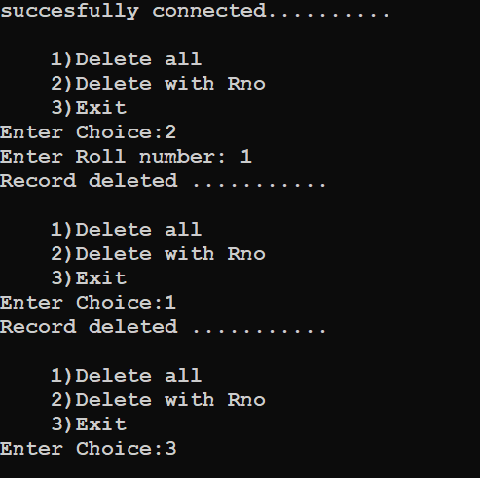

Q. Define a function display() to display all the records of the table class_12 of database school.

CODE
import mysql.connector as c
con=c.connect(host='localhost',user='root',password='',database='school',charset='utf8')
if con.is_connected():
print('succesfully connected..........')
cursor=con.cursor()

def display():
try:
cursor.execute('desc class_12')
recs=cursor.fetchall()
print(recs[0][0].ljust(6),recs[1][0].ljust(15),recs[2][0].ljust(10),recs[3][0].ljust(10),recs[4][0].ljust(10),\
sep='')
Que='select * from class_12'
cursor.execute(Que)
w=cursor.fetchall()
for rec in w:
print(str(rec[0]).ljust(8),rec[1].ljust(20),str(rec[2]).ljust(10),rec[3].ljust(10),rec[4].ljust(10),sep='')
except Exception as error:
print('Error :- ',error)

display()

OUTPUT

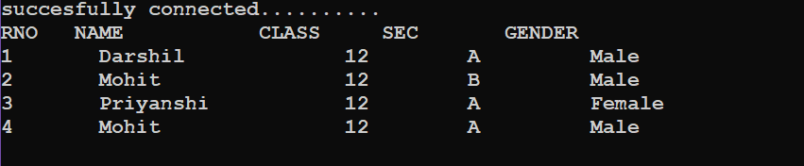

Q. Write a python program to display the records of the student of sec A of table class_12 in database school.

CODE
import mysql.connector as c
con=c.connect(host='localhost',user='root',password='',database='school',charset='utf8')
if con.is_connected():
print('succesfully connected..........')
cursor=con.cursor()
print()
print('Records of the student of section A :- ')
print()
cursor.execute('desc class_12')
recs=cursor.fetchall()
print(recs[0][0].ljust(6),recs[1][0].ljust(15),recs[2][0].ljust(10),recs[3][0].ljust(10),recs[4][0].ljust(10),sep='')
que='select * from class_12 where sec="A" '
cursor.execute(que)
dat=cursor.fetchall()
for rec in dat:
print(str(rec[0]).ljust(8),rec[1].ljust(20),str(rec[2]).ljust(10),rec[3].ljust(10),rec[4].ljust(10),sep='')

OUTPUT
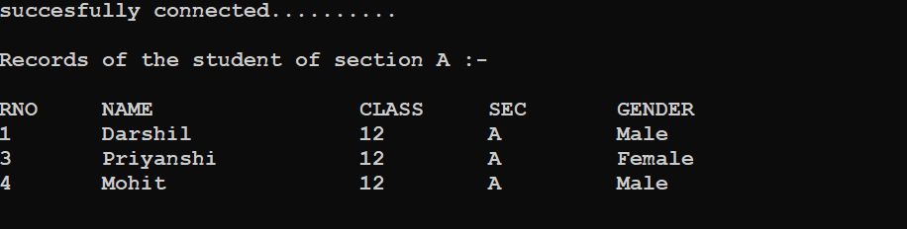

Q.Write a python program to delete the records of the students of sec A from table class_12 in database school and then display the content of the table .

CODE
import mysql.connector as c
con=c.connect(host='localhost',user='root',password='',database='school',charset='utf8')
if con.is_connected():
print('succesfully connected..........')
cursor=con.cursor()
print()
que='delete from class_12 where sec="A" '
cursor.execute(que)
con.commit()
cursor.execute('desc class_12')
recs=cursor.fetchall()
print(recs[0][0].ljust(6),recs[1][0].ljust(20),recs[2][0].ljust(10),recs[3][0].ljust(10),recs[4][0].ljust(10),sep='')
que='select * from class_12 '
cursor.execute(que)
dat=cursor.fetchall()
for rec in dat:
print(str(rec[0]).ljust(6),rec[1].ljust(20),str(rec[2]).ljust(10),rec[3].ljust(10),rec[4].ljust(10),sep='')
OUTPUT

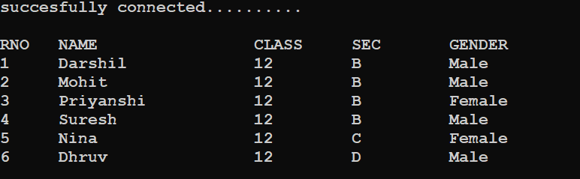

Q. Write a python program that display the first three rows fetched from class_12 table of MYSQL database school.

CODE
import mysql.connector as c
con=c.connect(host='localhost',user='root',password='',database='school',charset='utf8')
if con.is_connected():
print('succesfully connected..........')
crsr=con.cursor()
print()
crsr.execute('desc class_12')
recs=crsr.fetchall()
print(recs[0][0].ljust(6),recs[1][0].ljust(20),recs[2][0].ljust(10),recs[3][0].ljust(10),recs[4][0].ljust(10),sep='')
que='select * from class_12 '
crsr.execute(que)
dat=crsr.fetchmany(3)
for rec in dat:
print(str(rec[0]).ljust(6),rec[1].ljust(20),str(rec[2]).ljust(10),rec[3].ljust(10),rec[4].ljust(10),sep='')
con.close()
OUTPUT

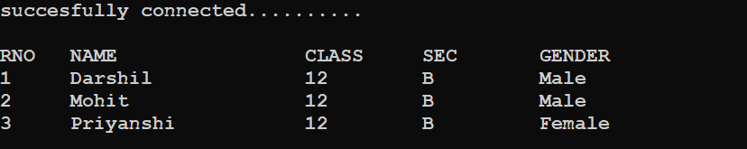

Q. Write a python program that deletes records from class_12 table of database school that have gender male and then display the contents of the table.

CODE

import mysql.connector as c
con=c.connect(host='localhost',user='root',password='',database='school',charset='utf8')
if con.is_connected():
print('succesfully connected')
cursor=con.cursor()
que='delete from class_12 where gender="Male" '
cursor.execute(que)
con.commit()
print('DISPLAYING THE RECORDS……')
print()
cursor.execute('desc class_12')
recs=cursor.fetchall()
print(recs[0][0].ljust(8),recs[1][0].ljust(20),recs[2][0].ljust(10),recs[3][0].ljust(10),recs[4][0].ljust(10),sep='')
Que='select * from class_12'
cursor.execute(Que)
w=cursor.fetchall()
for rec in w:
print(str(rec[0]).ljust(8),rec[1].ljust(20),str(rec[2]).ljust(10),rec[3].ljust(10),rec[4].ljust(10),sep='')

OUTPUT

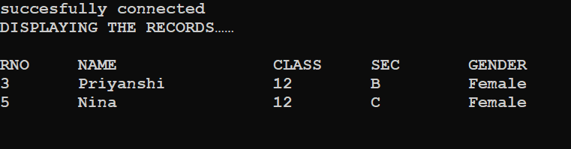

Stack

Q. Python program to implement stack operations.

CODE:-

def push(s,x):
global top
s.append(x)
top=len(s)-1

def pop(s):
global top
if len(s)==0:
print("Underflow")
else:
x=s.pop()
print("poped ",x)
if len(s)==0:
top=None
else:
top=len(s)-1

def display(s):
global top
if len(s)==0:
print("stack is empty")
else:
print("Stack elements....")
for a in range (top,-1,-1):
print(s[a])

stack=[]
top=None
while True:
print("\nStack operations")
print("1.Push")
print("2.Pop")
print("3.Display")
print("4.Exit")
print('top is',top)
ch=int(input("Enter choice : "))
if ch==1:
item=int(input("Enter data : "))
push(stack,item)
elif ch==2:
pop(stack)
elif ch==3:
display(stack)
else:
break
OUTPUT:-
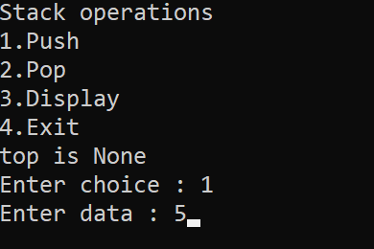
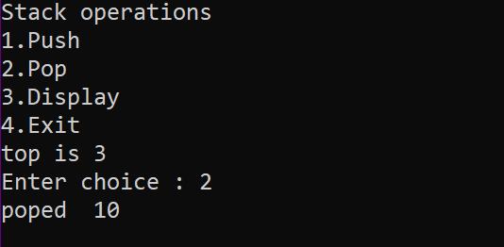
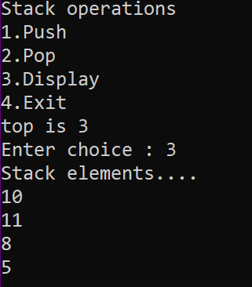

Q. Write a program to create a Stack for storing only odd numbers out of all the numbers entered by the user.Display the content of the Stack along with the largest odd number in the Stack
CODE:-
def push(stack, item):
stack.append(item)
def pop(stack):
if stack==[]:
return
return stack.pop()
def oddStack(num):
if num%2==1:
push(stack,num)
def GetLargest(stack):
elem=pop(stack)
large=elem
while elem!=None:
if large<elem:
large=elem
elem=pop(stack)
return large
n=int(input("how many numbers? "))
stack=[] #empty stack
large= -99
for i in range(n):
number=int(input("Enter number: "))
oddStack(number)
print("Stack created is ", stack)
large=GetLargest(stack)
print("Largest number in stack",large)

OUTPUT:-
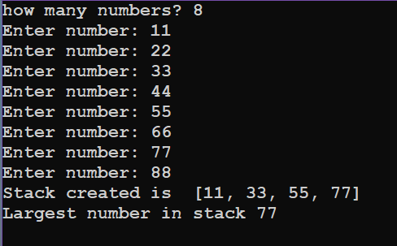

Q. Write a menu driven program that has functions PushS(lst) and PopS(lst)
for performing Push and Pop operations with a stack of List containing integers.
CODE:-
def PushS(lst):
n= int(input("Enter integer:"))
lst.append(n)
def PopS(lst):
if lst==[]:
print("Stack is empty--UNDERFLOW!")
else:
print ("Deleted value :",lst.pop())
lst=[]
while True:
print("""
1)PUSH
2POP
3)EXIT
""")
ch=int(input("Enter Option:"))
if ch==1:
PushS(lst)
elif ch==2:
PopS(lst)
elif ch==3:
break
else:
print("Wrong Option")
OUTPUT:-
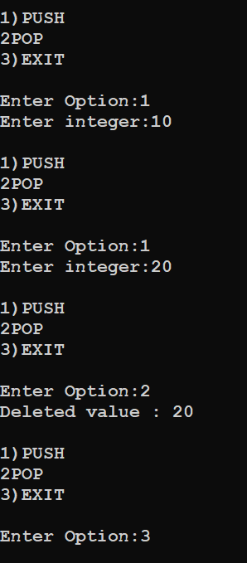

Q. Write a menu driven program that has functions Make Push (package) and MakePop(package) to add a new Package and delete & Package from a List of Package Description, considering them to act as push and pop operations of the Stack
CODE:-
def MakePush(package):
a = int(input("Enter package title: "))
package.append(a)
def MakePop(package):
if package==[]:
print("Stack empty")
else:
print ("Deleted element:",package.pop())
package=[]
while True:
print("""
1)PUSH
2)POP
3)EXIT
""")
ch=int(input("Enter Option:"))
if ch==1:
MakePush(package)
elif ch==2:
MakePop(package)
elif ch==3:
break
else:
print("Wrong Option")
OUTPUT:-
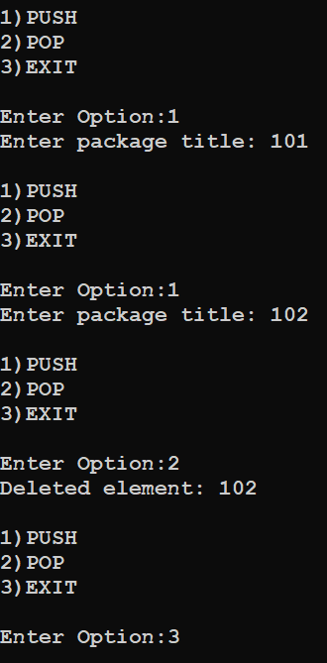

Q. Write a program to implement a stack for these book details(Bookno, book name). That is now each item node of the stack contains two types of information-a bookno and its name.Just implement Push and display operations.
def Push(stk,item):
stk.append(item)
top=len(stk)-1
def Display(stk):
if stk==[]:
print("Stack empty")
else:
top=len(stk)-1
print(stk[top],"<-top")
for a in range(-2,-top-2, -1):
print(stk[a])

stack=[]
top=None
while True:
print("STACK OPERATIONS")
print("1. Push")
print("2. Display stack")
print("3. Exit")
ch=int(input("Enter your choice (1-5) :"))
if ch==1:
bno=int(input("Enter Book no. to be inserted :"))
bname=input("Enter Book name to be inserted :")
item=[bno, bname]
Push(stack,item)
elif ch==2:
Display(stack)
elif ch==3:
break
else:
print("Invalid choice!")
OUTPUT:-
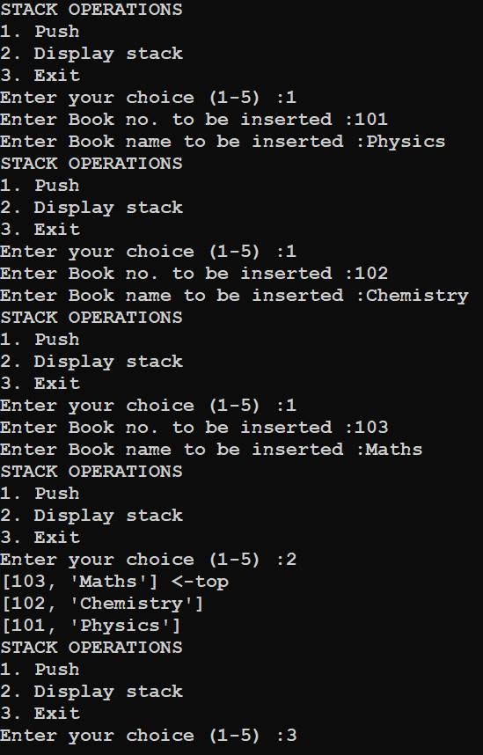
Q. Write a program to perform insert and delete operations on a Queue containing Members details as given in the following definition of itemnode:

MemberNo : integer
MemberName : String
Age : integer
CODE:-
def isEmpty(Qu):
if Qu==[]:
return True
else :
return False

def Enqueue(Qu,item):
Qu.append(item)
if len(Qu)==1:
front=rear = 0
else:
rear=len(Qu) - 1

def Dequeue(Qu):
if isEmpty(Qu) :
return "Underflow"
else:
item= Qu.pop(0)
if len(Qu) == 8:
front=None
rear=None
return item
def Display(Qu):
if isEmpty(Qu):
print("Queue Empty!")
elif len(Qu)==1:
print(Qu[0], "<== front, rear")
else:
front=0
rear=len(Qu)-1
print(Qu[front],"<--front")
for a in range(1, rear):
print (Qu[a])
print (Qu[rear], "<-rear")
queue=[]
front=None
while True:
print("QUEUE OPERATIONS")
print("1. Enqueue")
print("2. Dequeue")
print("3. Display queue")
print("4. Exit")
ch= int(input("Enter your choice (1-5): "))
if ch==1:
print("For the new member, enter details below:")
memberNo= int(input("Enter member no :"))
memberName=input("Enter member name :")
age = int(input("Enter member's age :"))
item=[memberNo,memberName,age]
Enqueue(queue,item)
input("Press Enter to continue...")
elif ch==2:
item=Dequeue(queue)
if item=="Underflow":
print("Underflow! Queue is empty!")
else:
print("Dequeue-ed item is", item)
input("Press Enter to continue...")
elif ch==3:
Display (queue)
input("Press Enter to continue...")
elif ch == 4:
break
else :
print("Invalid choice!")
input("Press Enter to continue...")
OUTPUT:-
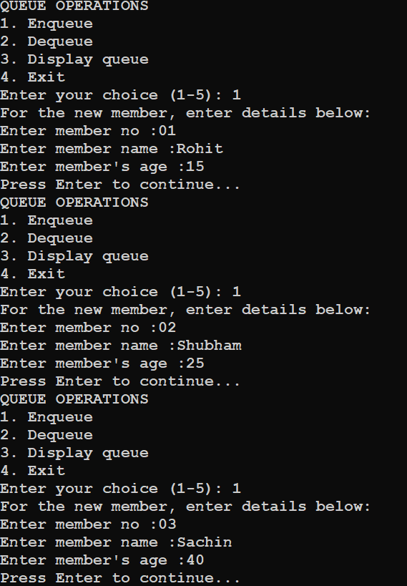
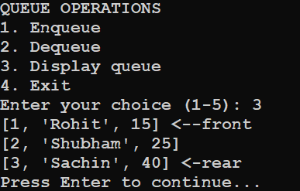
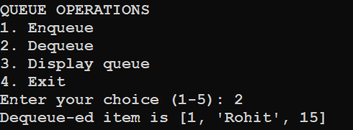

Q.Write a function in Python,INSERTQ(arr,data) and DELETEQ(Arr) for performing insertion and deletion operations in a Queue. arr is the list used for implementing queue and data is the value to be inserted.
CODE:-
def INSERTQ(arr):
data =int(input("Enter data to be inserted: "))
arr.append(data)

def DELETEQ(arr):
if arr== []:
print("Queue empty")
else:
print ("Deleted element is:", arr[0])
arr.pop(0)
arr=[]
while True:
print("""
1)INSERTQ
2)DELETEQ
3)EXIT
""")
ch=int(input("Enter Option:"))
if ch==1:
INSERTQ(arr)
elif ch==2:
DELETEQ(arr)
elif ch==3:
break
else:
print("Wrong Option")
OUTPUT:-
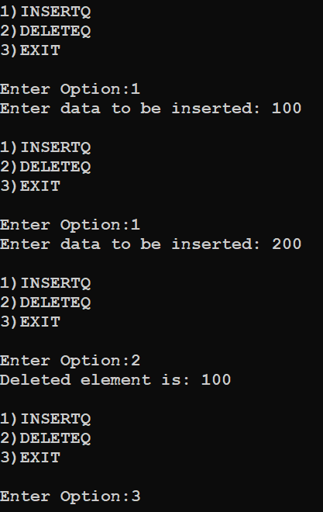

Q.Given the following tables for a database LIBRARY :
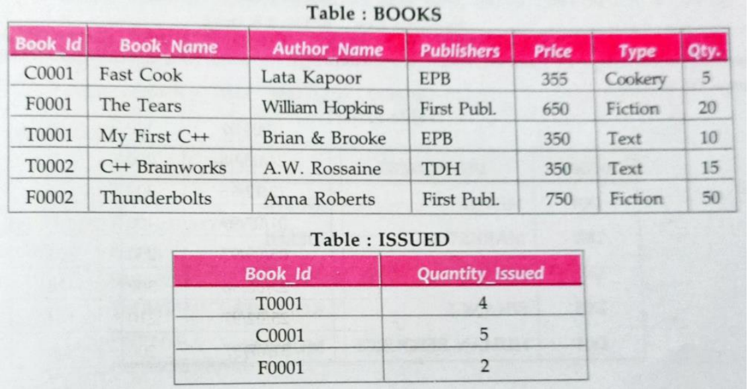

Write SQL queries for (a) to (f):

- To show Book name , Author name and Price of books of First Publc publishers.

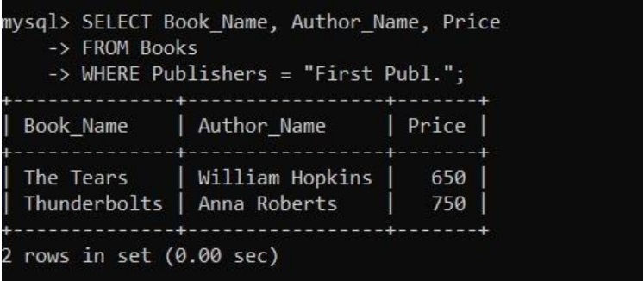

- To list the names from books of text type.

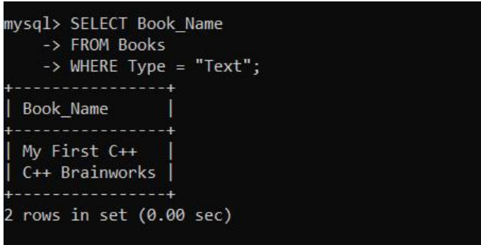

- To display the names and prices from books in ascending order of their price.

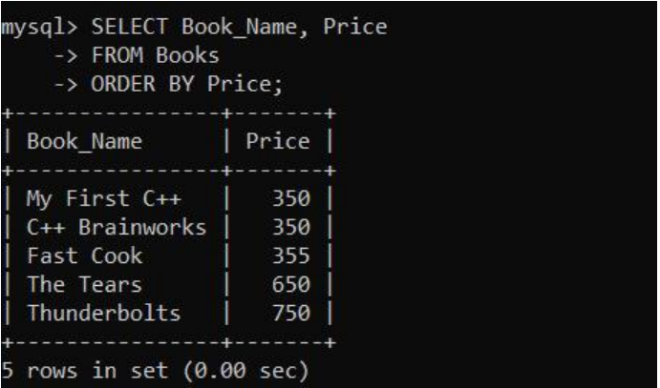

- To increase the price of all books of EPB Publishers by 50 .

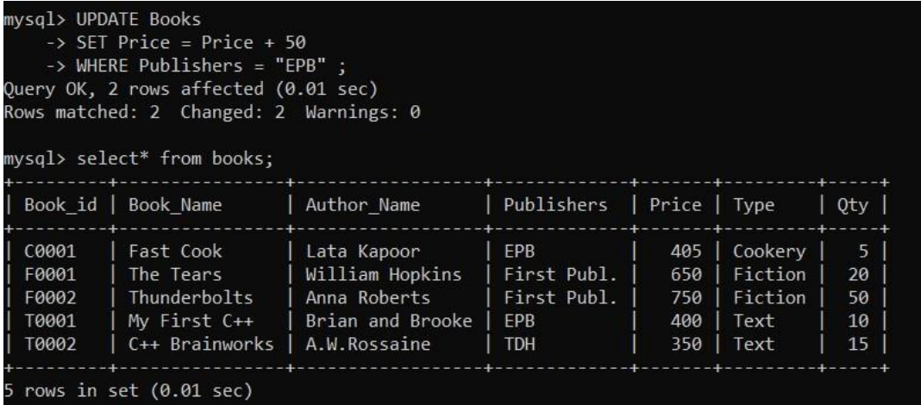

- To display the Book_id,Book_Name and Quantity_Issued for all books which have been issued.(The query will require contents from both the tables.)

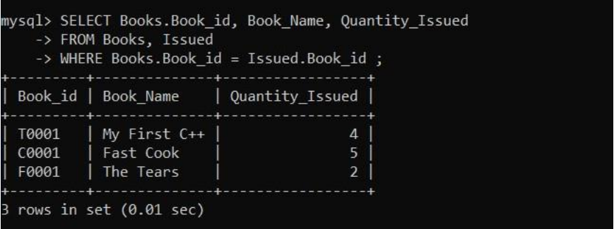

- To insert a new row in the table Issued having the following data : "F0003",1

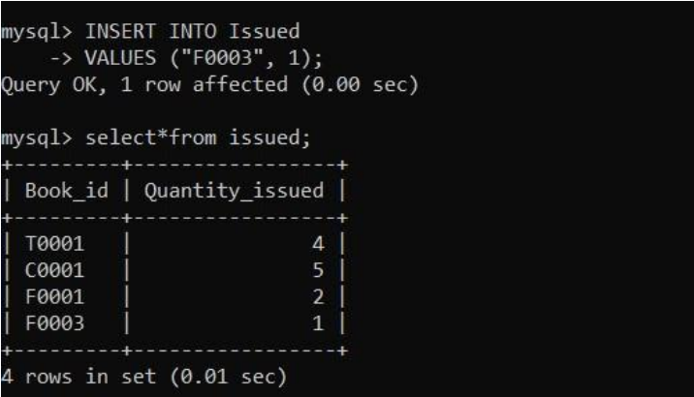

Q. Consider the following tables FACULTY and COURSES. Write SQL commands for the statements (i) to (vii).
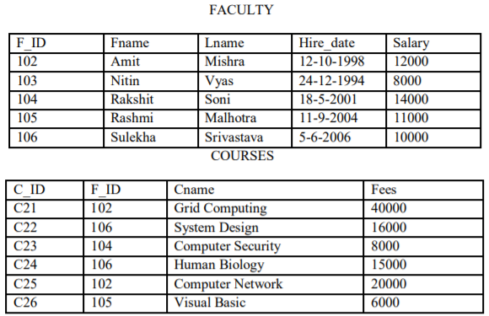
i) To display details of those Faculties whose salary is greater than 12000.
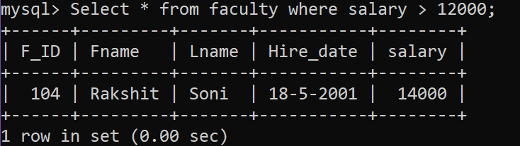
ii) To display the details of courses whose fees is in the range of 15000 to 50000 (both values included).
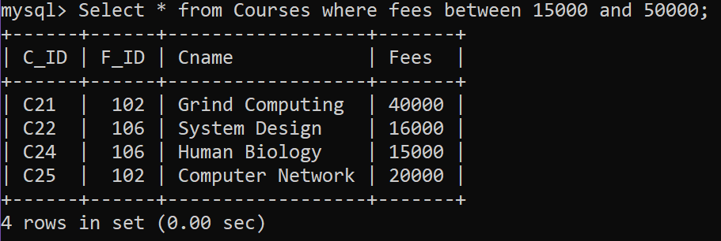
iii) To increase the fees of all courses by 500 of “System Design” Course.
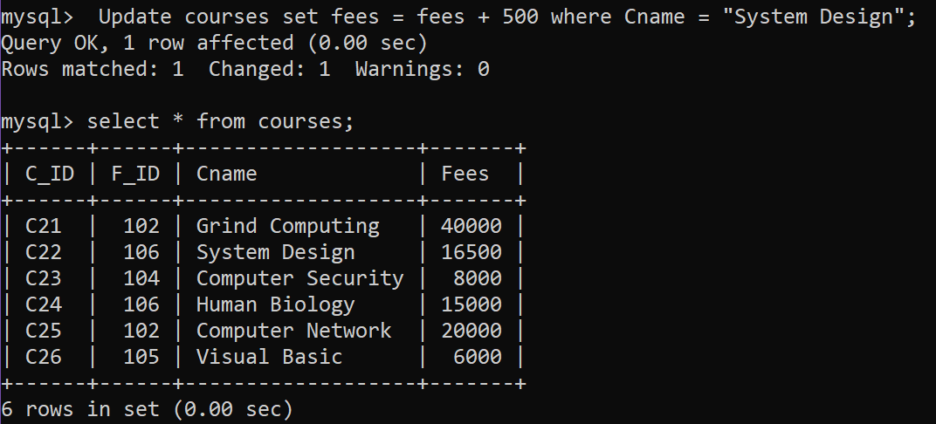
iv) To display details of those courses which are taught by ‘Sulekha’ in descending order of courses.
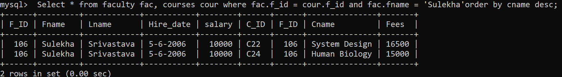
v) To count all record with F_ID
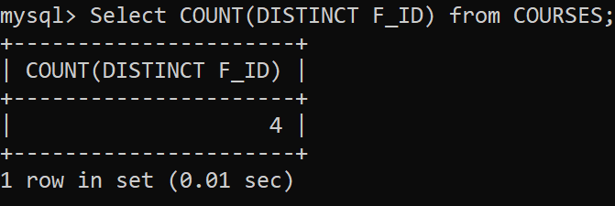

vi) To display Fname, Cname from FACULTY, COURSES where F_ID is same.

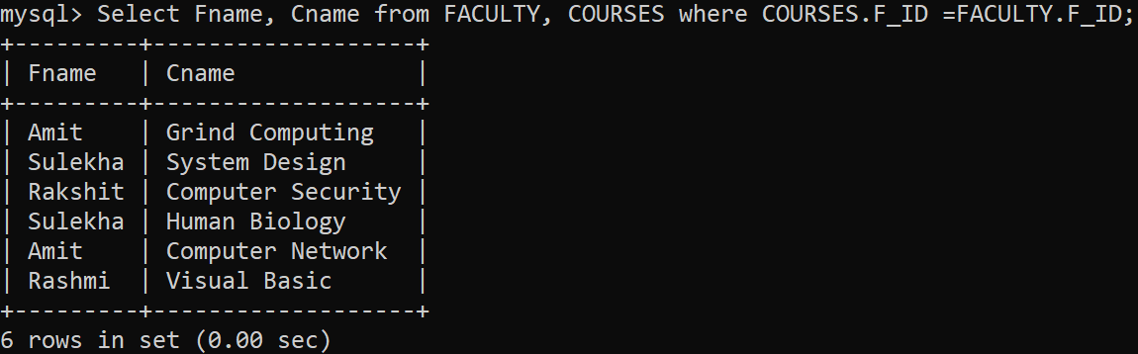

Q. Consider the following tables GAMES and PLAYER. Write SQL commands for the statements (i) to (viii) .
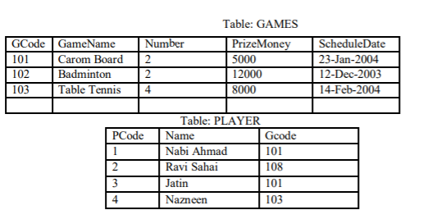
(i) To display the name of all Games with their Gcodes.
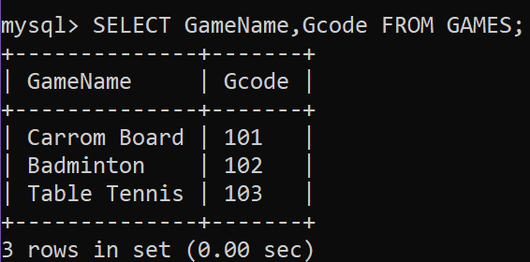
(ii) To display details of those games which are having PrizeMoney more than 7000.
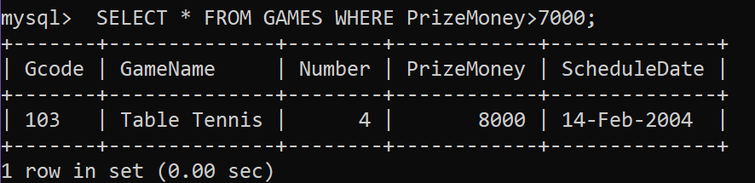
(iii) To display the content of the GAMES table in ascending order of Prize.
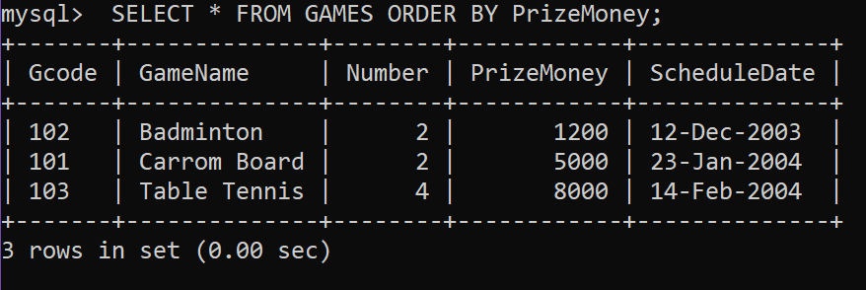
(iv) To display sum of PrizeMoney for each of the Number of participation groupings (as shown in column Number 2 or 4).
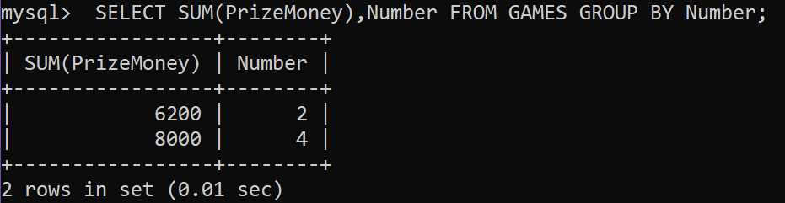
(v) To display the Count of different games from games;
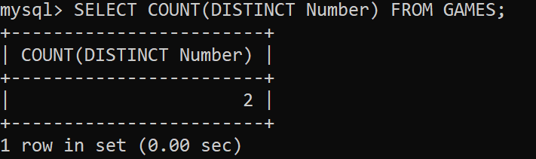
(vi) To display the Maximum PrizeMoney and Average of PrizeMoney from Games
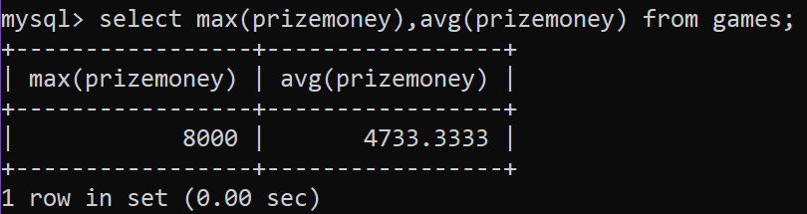
(vii) SELECT SUM(PrizeMoney) FROM GAMES;
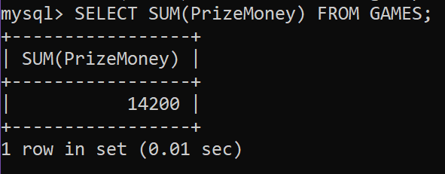
(viii) To display different GCode From Player
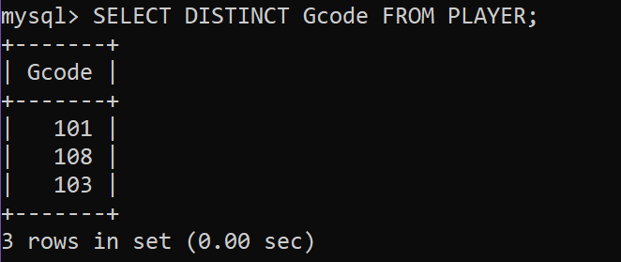

Q. Consider the following tables ITEM and CUSTOMER. Write SQL commands for the statements (i) to (v).
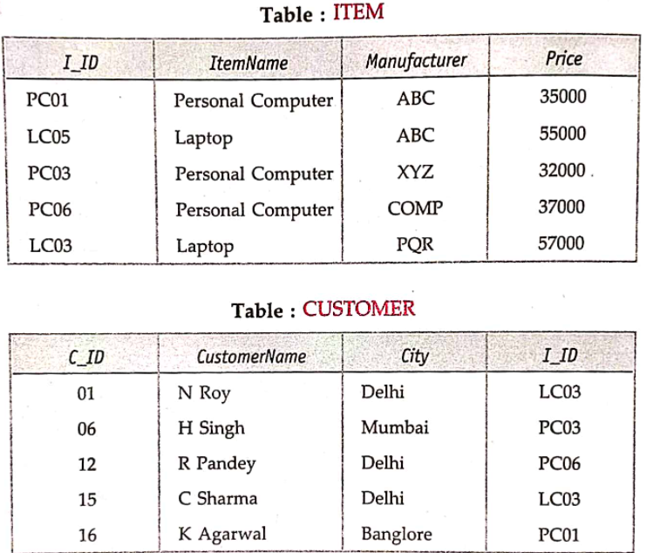
(i)To display distinct cities of customers
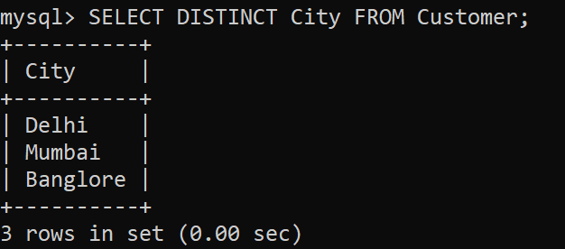
(ii)To display Name of the items,maximum price and no. of records with same Item Name in table Item
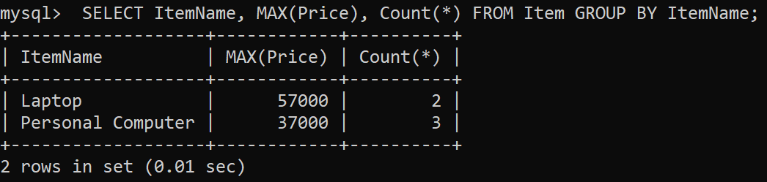

(iii) To display customer name brought the item and their manufacturers
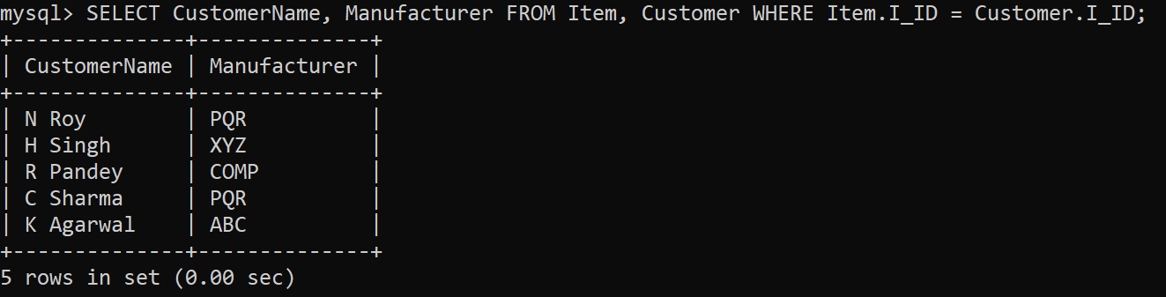
(iv) To display item name and price*100 by ABC manufacturer from Item Table
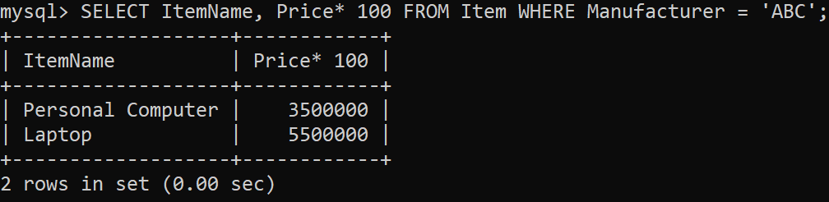
(v) To display average price of items from item table
